YEAR 7 SCIENCE
EARTH AND SPACE SCIENCES
INVESTIGATION - REFINING AN ORE

Aim: To recover a metal from its ore.

Materials: • 2M sulphuric acid (2M H₂SO₄)
• Copper oxide and sand mix
• 2 x 100 mL beaker
• Stirring rod
• Filter funnel and filter paper
• Power pack, 2 x leads, 2 x alligator clips
• 2 x iron nails
• Bunsen burner
• Tripod and gauze mat
• Bench protector

Method: 1. Take 3 teaspoons of the copper oxide ore and place it into a 100 mL beaker.

2. Carefully add 40 mL of 2M sulphuric acid (2 M H₂SO₄).

3. Gently heat the beaker above a Bunsen for a few minutes.

DO NOT LET IT BOIL!

Safety note
Sulphuric acid is corrosive to the skin and a strong irritant to the eyes, nose and lungs. Do not breathe the fumes and wash the skin if exposed to the acid.

Stir it gently with a stirring rod.

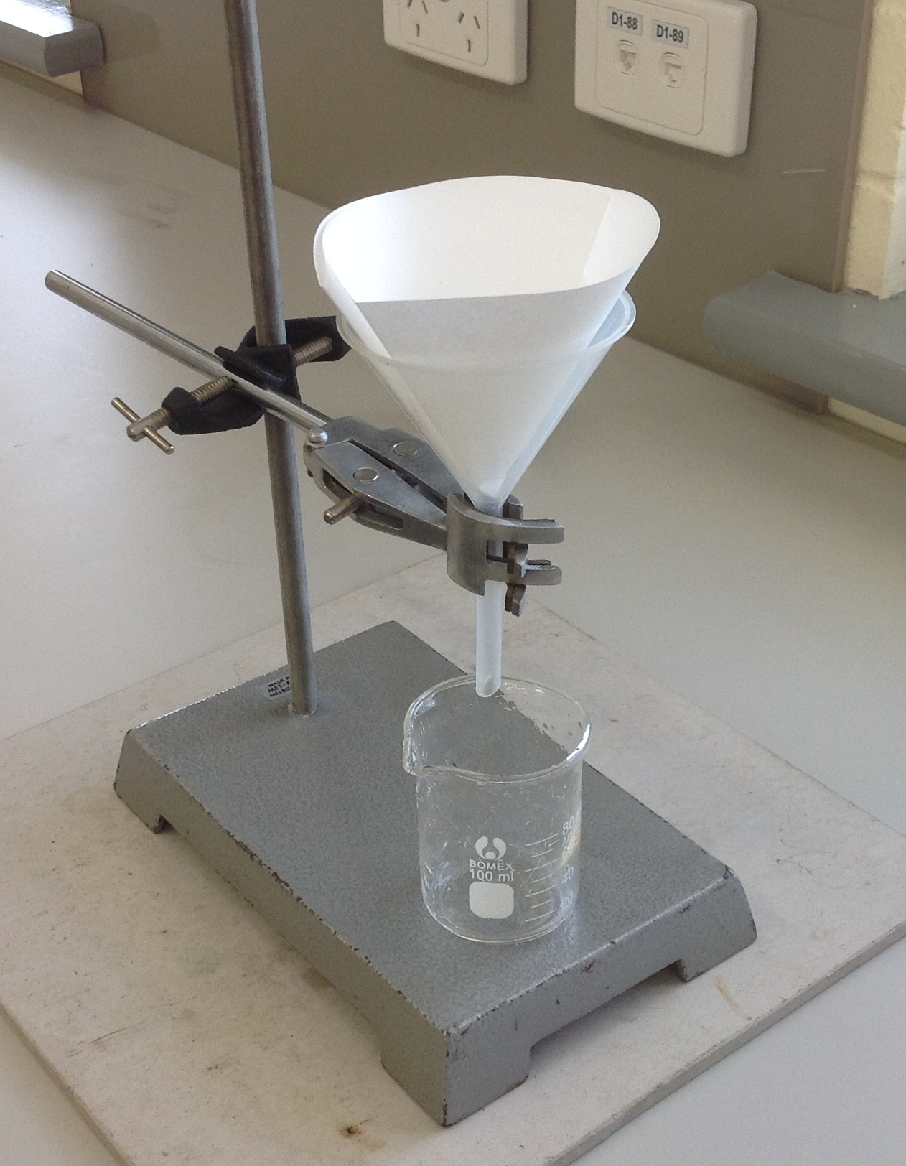
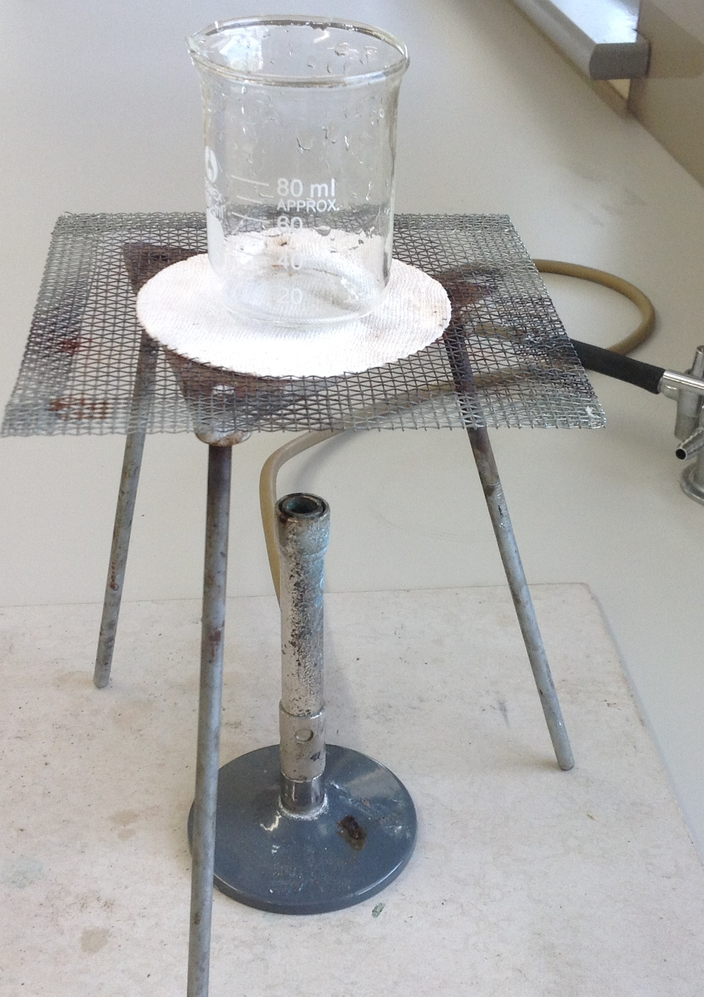

4. Allow the solution to cool and filter it into another 100 mL beaker.

5. Turn the power pack to 2V DC (use the red and black terminals) and attach the nails to the leads using the alligator clips.

6. Place the nails carefully into the solution.

DO NOT LET THE SOLUTION TOUCH THE ALLIGATOR CLIPS!
Safety note
The alligator clips will react with the solution if they come into contact. This must be avoided.

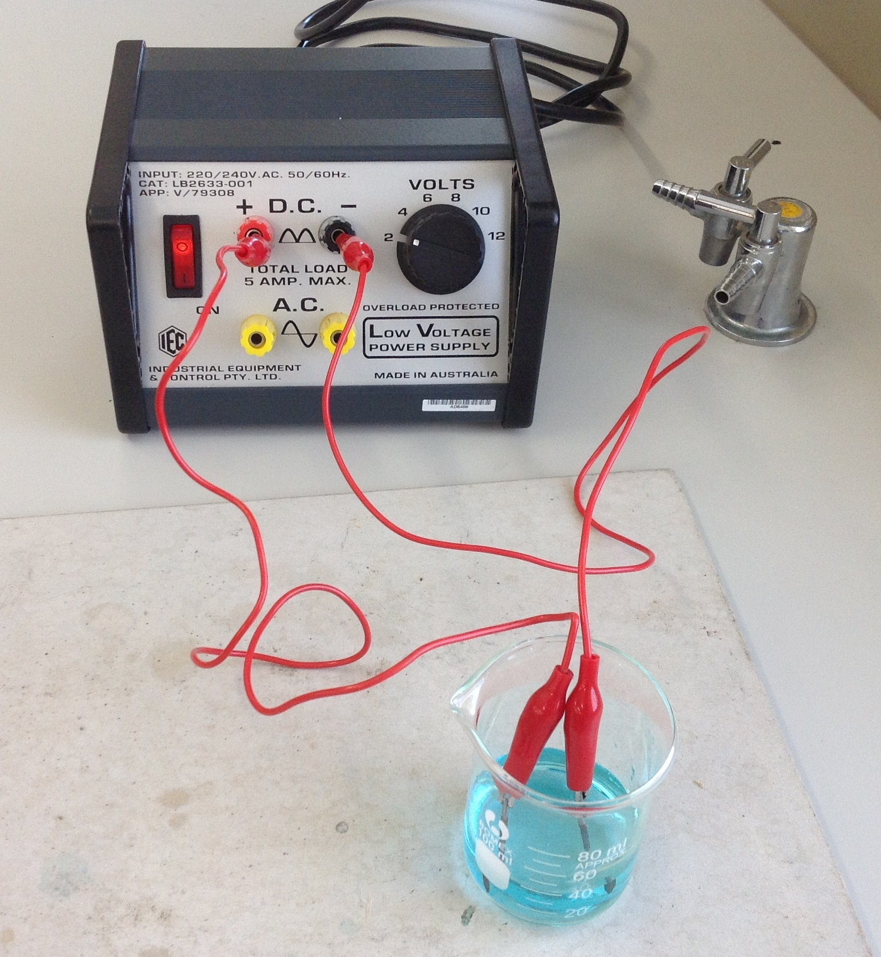

7. Observe what takes place at each nail.

Observations:

Discussion:

Conclusion:

